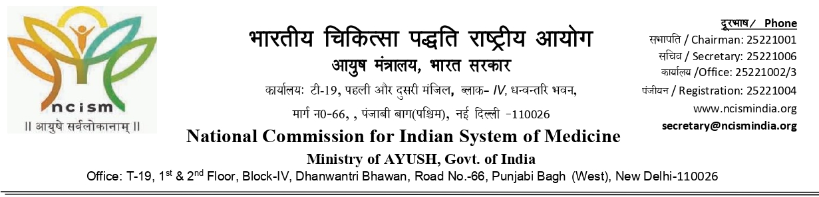
Hearing Notice
Øekad/ Ref. No. 4-70/MARB/2025-AY. fnukad/Dated: 23.07.2025

To,
The Principal,
Smt. Urmila Devi Ayurvedic College of Medical Sciences & Hospital,
UNA Road (10 Km), V & P.O Kharkan,
Distt. Hoshiarpur-146001, Punjab (Inst. ID-AYU0221)
E-mail:- 2002ayu0221@gmail.com

Subject:- Matter related to grant of hearing in respect of issuance of Extended permission to Smt. Urmila Devi Ayurvedic College of Medical Sciences & Hospital, UNA Road (10 Km), V & P.O Kharkan, Distt. Hoshiarpur-146001, Punjab (Inst. ID-AYU0221) with an intake capacity of 60 seats in UG (BAMS) course for the academic session 2026-27 under section 28 of NCISM Act, 2020 –reg.

Sir/Madam,

I am to here by state that, to verify the physical and other infrastructure facilities available at Smt. Urmila Devi Ayurvedic College of Medical Sciences & Hospital, UNA Road (10 Km), V & P.O Kharkan, Distt. Hoshiarpur-146001, Punjab (Inst. ID-AYU0221) for issuance of extended permission with an intake capacity of 60 seats in UG (BAMS) course for the academic session 2026-27, under section 28/29 of NCISM Act, 2020, your College was visited on 11.03.2025 and 12.03.2025 on Hybrid mode by the visitation team of the Medical Assessment & Rating Board, National Commission for Indian System of Medicine.

Further, in view of above, the college has been assessed on the basis of concerned regulations. On examining following shortcoming were observed:-

- Teaching staffs:-

- Availability of total teaching staff for UG ( BAMS) Course as per the part 1 submitted by the college is $\frac{Available}{Required}x100\%=\frac{25}{30}x100\%= 83.33$% (Excluding Excess)
- Shortcoming is as under-

S.  No. | Department | Minimum Requirement as per Regulations  (for UG upto 60 seats) | No. Of Existing Teachers |  |  |  |  | Shortcomings of HF and LF
 |  |  | Professor | Asso. Prof. / Reader | Asst. Prof. / Lecturer | Total | Excess
 | Rachana Sharir | 1P or 1R  +1L | 0 | 0 | 2 | 2 |  | 1HF
 | Rog Nidan avum Vikriti Vigyan | 1P or 1R  +1L | 0 | 0 | 1 | 1 |  | 1HF
 | Agad Tantra avum Vidhi Vaidyaka | 1P or 1R  +1L | 0 | 1 | 0 | 1 |  | 1LF
 | Kaumar bhritya-Bala Roga | 1P or 1R  +1L | 0 | 0 | 1 | 1 |  | 1HF
 | Kayachikitsa | 1P and 1R  +1L | 0 | 2 | 1 | 3 |  | 1P

Accordingly, the aforementioned shortcomings/defects found in the assessment report was informed to you vide letter of even no. dated 19.06.2025. In response of the same you have submitted the clarification vide letter ref. No. SUDACMS/2025-26/177 dated 20-06-2025.

In view of the clarification submitted by the you, assessment report has been carefully examined once again in terms of concerned Regulation and provisions under the NCISM Act, 2020 and relevant regulations thereunder, and after verification the assessment report along with clarification the report was again placed in the 134th Board meeting of Medical Assessment and Rating Board for Indian System of Medicine (NCISM) held on 16.07.2025. On careful examination of the assessment report, as per the regulation 55 (14) of MESAR for Undergraduate Ayurveda, 2024 before issuing the order for seat reduction/denial of permission an opportunity of hearing shall be given to the institutions. Therefore, Board decided to provide an opportunity of hearing to your college for the observed shortcoming.

Therefore, you are hereby given an opportunity of hearing on 19.06.2025 to appear before the designated Hearing Committee as appointed by President, Medical Assessment and Rating Board, NCISM and present your case and clarify the above position and to show cause as to why not the permission to your college for intake capacity with 100 seats in UG (BAMS) course for the academic session 2026-27 under section 28/29 of NCISM Act, 2020 be denied.

Hearing, will be done virtually i.e., through video conferencing and the link, timing and other details of the same will be communicated separately.

It is further directed that you may make oral as well as written submissions before the designated hearing committee and produce all relevant valid documents/records/proof in original (scanned format PDF) to substantiate your claims against all the deficiencies/shortcomings as indicated above and submit an authenticated copy for evidence/verifications to Medical Assessment and Rating Board for Indian system of Medicine on email i.e. president.marbism@ncismindia.org before 02:00 PM at 24.07.2025 as per necessity or in respect of shortcoming mentioned above only.

It may also be noted that no further hearing opportunity will be given in case you do not attend the hearing at the stipulated time and date. Further, it will be presumed that you have nothing to say and required necessary action in terms of the NCISM Act and the relevant regulations thereunder will be taken based on available records.

(B. L. Mehra)
Member, Medical Assessment and Rating Board for Indian System of Medicine
(NCISM)

Copy to:-

- The Chairperson, National Commission for Indian System of Medicine, T-19, 1st Floor, Block-IV, Dhanwantri Bhawan, Road No.66, Punjabi Bagh (West), New Delhi-110026.
- Guard file.

(B. L. Mehra)
Member, Medical Assessment and Rating Board for Indian System of Medicine
(NCISM)

